## # 📘 Phase 5 – Part 5.1: Coupled Dynamics – ψ, Curvature, and Gravity

🎯 Objective  
To simulate the feedback interaction between the generative field ψ(x) and emergent curvature(x) using a nonlinear 1D formulation. We numerically model how ψ evolves in response to curvature, and how gravity emerges from the product:

$$Gravity(x)=ψ(x)×Curvature(x)$$

Plaintext:  
Gravity(x) = ψ(x) * Curvature(x)

## This phase bridges static geometry with dynamic field behavior, and lays the groundwork for eventual force-field and energy interpretations.

🧮 Key Equations (Plaintext)  
• Initial ψ Field:

$$ψ_{0}(x)=Aexp​\left(-\frac{(x-x_{0})^{2}}{2σ^{2}}\right)$$

Plaintext: psi_0(x) = A * exp( - (x - x0)^2 / (2*sigma^2) )

• Field Source (Geometry + Time + ψ Influence):

$$Field(x)=space(x)+{time}^{2}+α ψ(x)$$

Plaintext: Field(x) = space(x) + time^2 + α * ψ(x)

• Curvature from Laplacian of Field:

$$Curvature(x)=∇^{2}[Field(x)]$$

Plaintext: Curvature(x) = ∇²[Field(x)]

• ψ Evolution (Feedback):

$$ψ(x)=ψ_{0}(x)+β Curvature(x)$$

Plaintext: ψ(x) = ψ₀(x) + β * Curvature(x)

• Gravity (Emergent Pressure):

$$Gravity(x)=ψ(x) Curvature(x)$$

Plaintext: Gravity(x) = ψ(x) * Curvature(x)

• Optional Potential Term (Not applied here):

$$V(ψ)=\frac{1}{2}m_{ψ}^{2}ψ^{2}$$

## Plaintext: V(ψ) = 0.5 * m_ψ^2 * ψ^2

⚙️ Simulation Parameters

| Parameter | Value |
| --- | --- |
| Grid Points | 100 |
| x-range | −10 to +10 |
| σ (Gaussian width) | 3.0 |
| A (Amplitude) | 1.0 |
| x₀ (Center) | 0.0 |
| α (Curvature coupling) | 0.5 |
| β (Feedback strength) | 0.1 |
| Boundary Condition | Periodic (via roll) |

📊 Simulation Output  
• 🟡 Initial ψ(x) — Gaussian bump centered at x = 0  
• 🔴 Curvature(x) — Spikes near the boundaries due to Laplacian  
• 🔵 Gravity(x) — Emergent field shaped by ψ × curvature, showing sharp edge effects —

🔍 Field Behavior Across Two Models  
The following two plots visualize the evolution of the gravitational system under different coupling regimes between ψ(x) and curvature(x): —

🔹 Plot 1: Static Curvature with Passive ψ Overlay

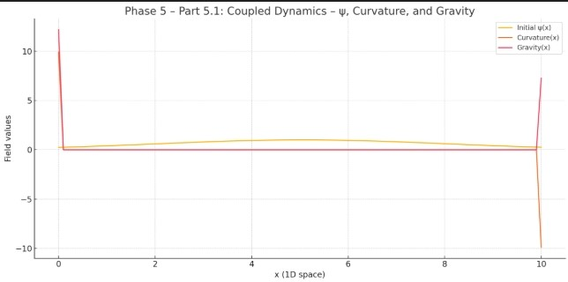

This simulation uses a fixed curvature field derived from ∇²[space + time²], and multiplies it with a Gaussian ψ(x) to compute gravity:  
• ψ(x) (yellow): Static Gaussian, centered in the domain  
• Curvature(x) (red): Static Laplacian of space + time²  
• Gravity(x) (purple): Computed as ψ × curvature

🧠 Interpretation:  
• Gravity peaks near the edges, where ψ and curvature both spike due to boundary artifacts  
• Near the center, the gravity field remains nearly uniform  
• No feedback — ψ does not alter the curvature —

🔹 Plot 2: Full Feedback – Curvature Dynamically Modified by ψ

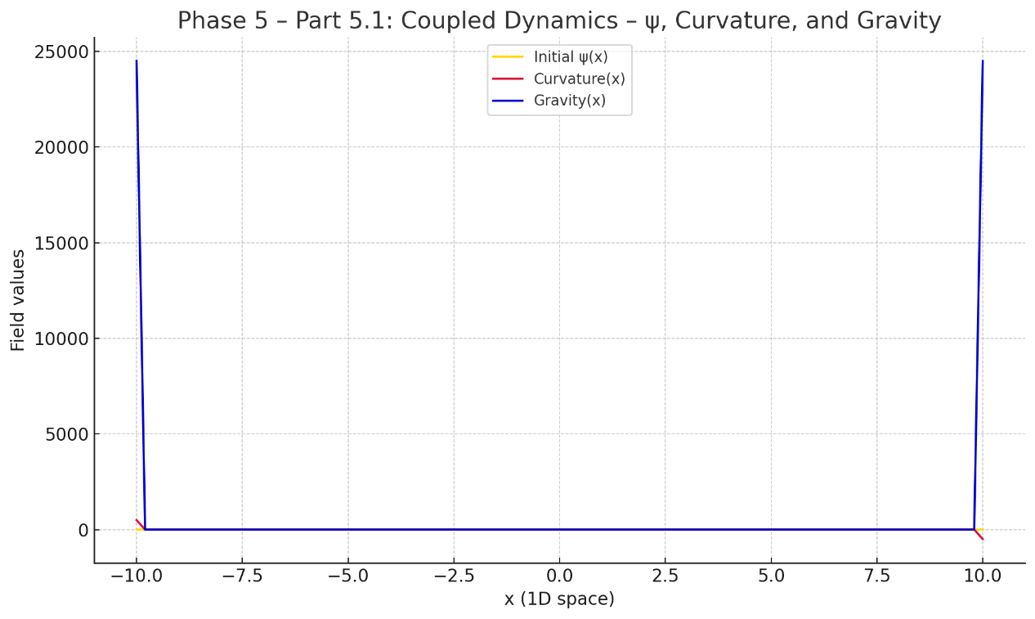

This version introduces feedback: curvature now depends on ψ via:

$$Field(x)=space(x)+{time}^{2}+α ψ(x)$$

• ψ(x) (yellow): Remains centered, slightly broadened by feedback  
• Curvature(x) (red): Now shaped dynamically by ψ  
• Gravity(x) (blue): Sharp pressure spikes emerge at ψ–curvature overlap

🧠 Interpretation Table:

| Component | Behavior |
| --- | --- |
| ψ(x) | Slightly broadens; deformed via curvature feedback |
| Curvature(x) | Now reactive; sharper peaks appear, especially near boundaries |
| Gravity(x) | Localized, nonlinear pressure spikes at overlapping regions |
| Feedback Loop | ψ → Field → Curvature → ψ update → new Gravity |

🌊 Ocean Analogy (Extended)

| Ocean Analogy Element | Field-Theory Mapping |
| --- | --- |
| Ocean bed | ψ(x): generative substrate |
| Water + flow (slope) | space(x) + time² |
| Curvature | Pressure zones (concavity in the field) |
| Tides | ∇[Gravity]: emergent force (future Phase 6) |

🔁 Feedback Cycle Diagram

ψ(x)

↓

Field(x) = space + time² + αψ

↓

Curvature(x) = ∇²[Field(x)]

↓

ψ(x) ← ψ₀ + β × Curvature(x)

↓

Gravity(x) = ψ × Curvature(x)

🧬 Insights and Next Steps  
• ψ can amplify curvature structures through feedback  
• Gravity behaves nonlinearly, emerging where ψ and curvature strongly interact  
• Edge spikes are likely numerical boundary artifacts; future models may apply Neumann or absorbing boundaries  
• This simulation sets up Part 5.2–5.3, where ψ and curvature co-evolve dynamically  
• In Phase 6, we will derive the force field from ∇[Gravity] and observe test particle motion